# **PLASMIX**

Plastics Derived Fuel

PLASMIX

Summary

Sample pictures

Provisional Lab test report

### Summary

Plasmix is a fuel produced from various types of selected plastics, categorically excluding PVC. It constitutes the non-further recyclable portion of solid wastes, industrial wastes or commercial wastes.

|  |  |
| --- | --- |
| **Material** | **Plasmix** |
| Description | Mixed soft plastics, produced by collection and baling of non-recyclable plastics (not including PVC), labels, and other soft plastics materials. |
| Packaging | Bales, abt cm 70x120 (indicative, any industry standard size allowed) |
| Aspect | Solid |
| Individual pieces size | Up to 40-50 cm each |
| Classification | EWC code 19.12.04  HS Code (TARIC) 39159080  Annex VII regimen, green list |
| Recovery | Delivered strictly for recovery by Waste Framework Directive (2006/12/EC) method R1, energy recovery. Final plant to be certified for R1 operations. |
| Shipment | Depending on departure location for each producing plant:   * bulk baled in 2000-2500 metric tons vessel; * bulk baled in 40’ sea containers (abt 20 metric tons per box) |

### 

### Sample pictures

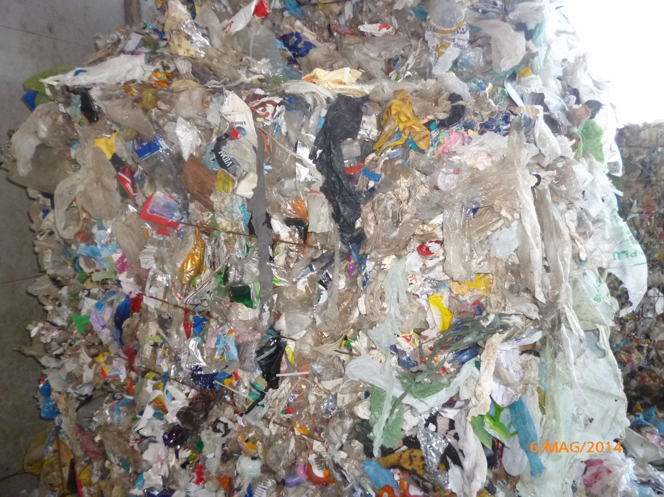

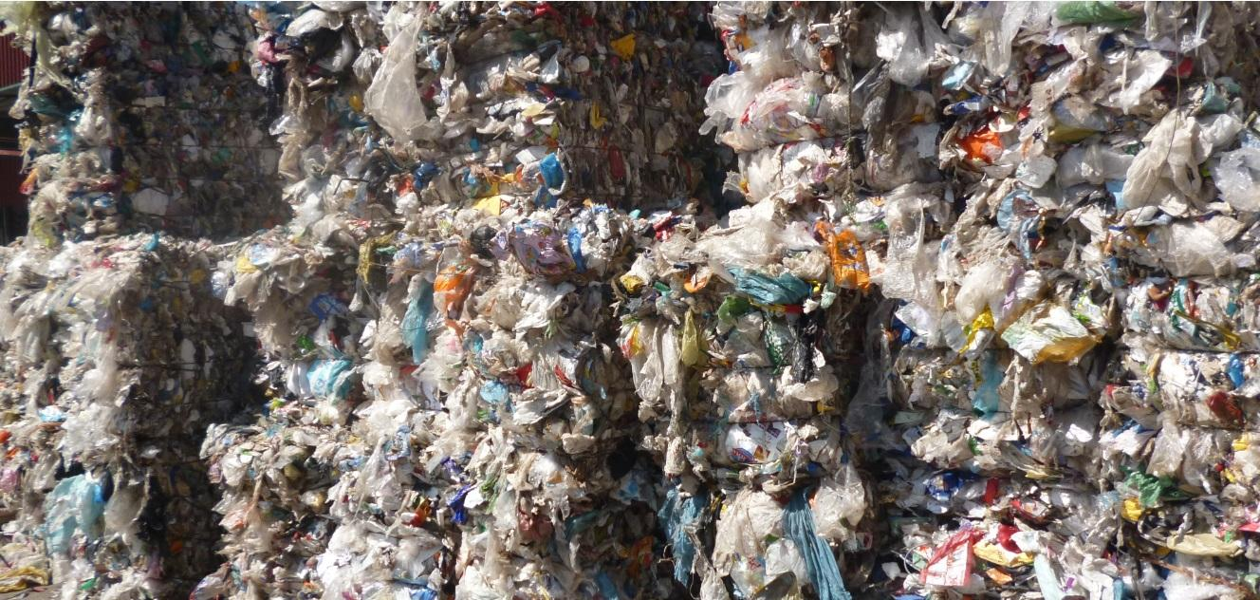

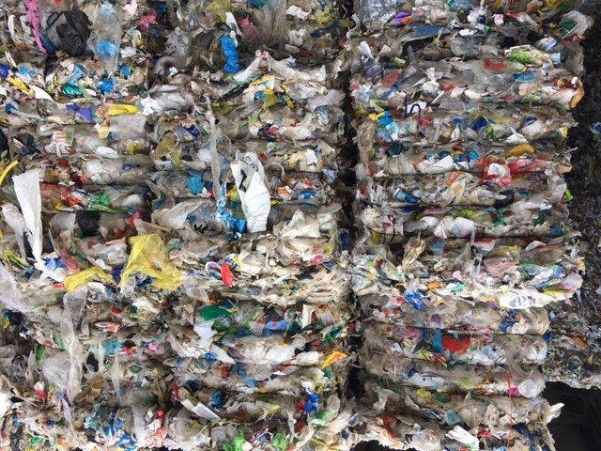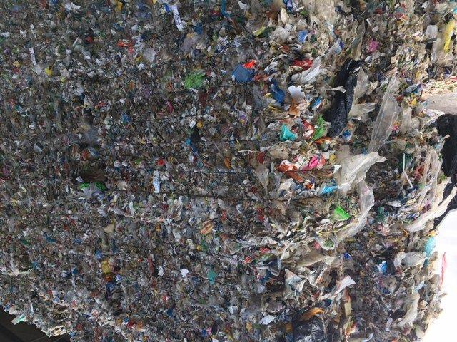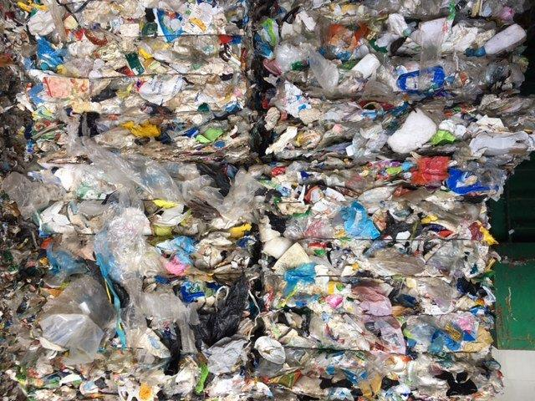

Medium Fine Coarse

### 

### Provisional Lab test report

The following report constitutes an average of five separate samplings, taken in different periods of time from the final Plasmix material produced, pursuant to UNI 9903-1:2004 sampling provisions. Being a reference only, the testing method has not been indicated.

|  |  |  |  |
| --- | --- | --- | --- |
| **Parameter** | **Indicative Value** | **Unit** | **Indicative range** |
| Lower Heating Value | 25930 | KJ/Kg | 22000 - 27000 |
| Moisture | 14.89 | g % (m/m) | 11- 15 |
| Ashes | 7.42 | g % | Max 20 |
| Arsenic (As) | < 0.50 | mg/kg | N/A |
| Cadmium (Cd) | < 0.50 | mg/kg | N/A |
| Chrome (Cr) | 4.30 | mg/kg | Max 10 |
| Sulphur (S) | 0.014 | mg/kg | Max 0.6 |
| Chlorine (Cl) | 1.43 | mg/kg | Max 2 |

[temizevren@greensley.eu](mailto:temizevren@greensley.eu)

[www.greensley.eu](http://www.greensley.eu)